**GLOBALISATION IS BROUGHT TO COURT**

**ROLE-PLAY**

**(РОЛЕВАЯ ИГРА)**

Урок в 11 классе

Учитель английского языка Цамаева Залина Сайпудиевна

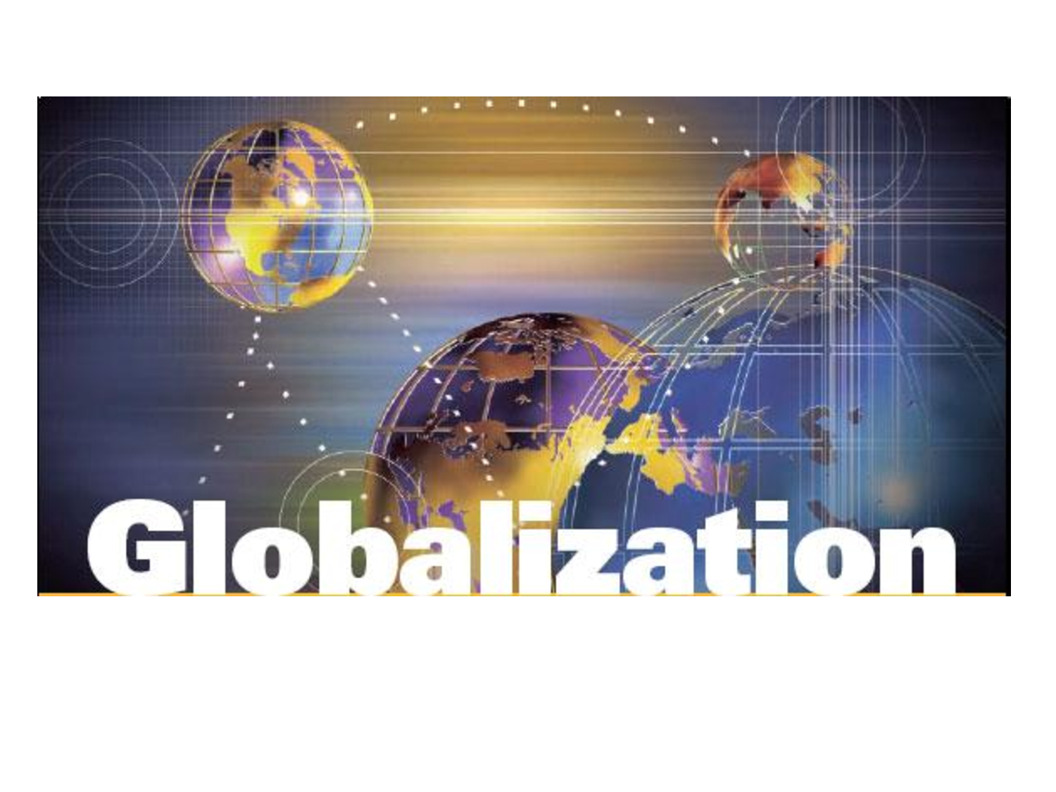

**ПОЯСНИТЕЛЬНАЯ ЗАПИСКА**

Урок «Globalisation is brought to court» является заключительным уроком по теме «Глобализация – за и против». В рабочей программе этой теме отведено 24 часа. Урок «Глобализация предстала перед судом» является двадцать четвертым и представляет собой урок обобщающего повторения.

Подготовка к этому уроку шла на протяжении всей III четверти в процессе работы с новыми лексическими единицами, усвоением новых грамматических тем (исчисляемые и неисчисляемые существительные, условные предложения II и III условия, фразовые глаголы…), чтения и обсуждения текстов по теме монологических высказываний по проблемам глобализации и т.д.

Только после усвоения теоретического материала, выполнения всех практических заданий, закрепления речевых образцов и отработки речевых навыков проведение нестандартного урока стало возможным.

Форма урока выбрана в соответствии с требованиями рабочей и государственной программ. Она способствует развитию навыка работы в группе и формированию коммуникативных, познавательных, информационных и социальных компетентностей обучающихся.

Разработанный урок соответствует требованиям общеобразовательной программы. При подготовке урока за основу был взят тематический материал УМК “Happy English.ru” для 11 класса авторов М. Кауфман и К. Кауфман..

Проведение заключительного урока в форме ролевой игры вызвало у учеников 11 а класса больше интереса, чем урок-проект.

Сложность данной формы урока для обучающихся заключалась в том, что они формировались в группы по 4 человека по принципу «за» или «против», не зная, какую роль они будут играть в «судебном процессе». Только судья знал о своей роли, и именно он представил на уроке «обвинителей», «защитников», «суд присяжных» и представителей общественности и объяснил их роль в процессе.

Группы формировались с учетом интересов и языковых возможностей обучающихся. Руководители групп были назначены учителем, и, конечно, – из наиболее сильных учеников.

**GLOBALISATION IS BROUGHT TO COURT.**

**ГЛОБАЛИЗАЦИЯ ПРЕДСТАЛА ПЕРЕД СУДОМ.**

**ROLE-PLAY.**

**Цель урока**:

* контроль сформированности навыков устной речи.

**Задачи урока:**

* развитие умения слушать, понимать и высказывать своё мнение.
* развитие умения планировать своё языковое поведение и умения делать оценочные высказывания по обсуждаемой проблеме;
* развитие умения трансформировать полученную информацию в новую ситуацию;
* формирование гражданской идентичности, развитие интереса к юридическим профессиям;
* воспитание чувства сопричастности к тому, что происходит в стране и в мире.

**ВСТУПИТЕЛЬНОЕ СЛОВО УЧИТЕЛЯ:**

Globalisation is a controversial issue for businesses and governments throughout the world. We recognize globalisation through its effects. It is a bit like electricity- we cannot see it, but we certainly observe what it does. That is why different groups of people interpret it in different ways.

For the opponents of globalisation it is a threatening word, which threatens the environment as well as national cultures. And the supporters believe that globalisation will bring prosperity and economic growth.

Well, boys and girls, we were reading, talking and writing about this phenomenon during a lot of classes. I believe everybody understands now what it is what advantages and disadvantages it can bring to the world.

Today we are going to have our final lesson. It will be a role-play "Globalisation is brought to court". Some of you will try to accuse globalisation and even reward it while some others will do their best to defend it. The judge and the jurry will help us be just and understanding.

Mind the meaning of the following words, please. They will help you in your work:

* a judge –судья
* a team of procecution – обвинение
* a team of defence – защита
* a jurry – присяжные
* a representative of the public - представитель общественности
* a technical assistant - технический помощник
* Your Honour -Ваша честь.
* I want to accuse globalisation of
* I am going to suit globalisation for
* I would claim globalisation to be blame of

Let me introduce the judge. Meet Victor Prokoshev in the part of the judge.

Take your place, please.

**Судья представляет участников процесса:**

Let me introduce the team of procecution. They are:....

The team of defence consists of : ...

Meet the jurry. They are:...

The public is represented by:...

... is the technical assistant.

**Вступительное слово судьи:**

Globalisation can be described as a process by which the people of the world are unified into a single society and function together. This process is a combination of economic, technological, sociocultural and political forces. It is a movement of people, goods, capital and ideas due to increased economic integration.

Let me declare the court open!

|  |
| --- |
| The first problem to be discussed is the impact globalisation produces on the economical development. The team of procecution has the floor and I ask the team of defence to present your point of view on this problem. |
| **Procecution** |
| Your Honour, the world of economy and even politics, is getting more and more controlled by multinational corporations. Local businesses are finding hard to compete with global ones, and have to close down. Places of work are taken away from small towns and villages. So, the level of unemployment is growing. We accuse globalisation of all these problems. ... |
| The problem of agriculture and farming is one of the most debatable today. Who is responsible for this problem? |
| It is difficult for domestic producers to compete with multinational corporations especially if it is an infant industry or farming. That is why framers’ markets are disappearing and we have to buy and eat the food, which is offered by countries with engineering agriculture So, people all over the world eat pizza, hamburgers, sushi, chicken Tikka Masala and other harmful things. We are sure globalisation is guilty of this process. |
| We all know that the world is suffering from pollution of the environment still more and more often. Most people are sure that it is the result of globalisation. And what is your point of view? |
| Your Honour, we are going to suit globalisation for its destructive actions against the whole mankind. More and more global problems connected with the pollution of the environment appear. There one peculiarity should be admitted - developed countries try to locate harmful for the environment factories and works not in their own countries but in developing ones. There may be a greater chance of diseases spreading worldwide. We should not forget about all kinds of dangerous disasters which are caused by the process of globalisation. |
| There is a firm belief that globalisation can destroy cultural diversity of not one but many countries. Can you object to this statement? |
| Yes, globalisation destroys cultural identity of not strong but developing countries. For example Europeans usually try to impose their customs and traditions on Asian people. So cultural diversity and individuality are disappearing. We buy clothes in the same shops, eat the same food, read the same books, and watch the same films. A lot of countries are already using English instead of their national language. |

**Обращение судьи к присяжным:**

Now I want the jurry to ask questions if you have any the procecution and the defence.

**The jurry:**

1 -How dangerous is globalisation for agriculture in Russia?

2 -Do you have any evidences of negative or positive effects of globalisation on our Russian identity?

**Ответы участников процесса…………..**

**Judge** -Thank you! And what is your verdict?

**Jurry**: -Your Honour, as you can see, the debate about the positive and negative aspects of globalisation will not be over soon, as both sides have their arguments.

Whatever our position is, globalisation is a process that is already happening. It has created the need for global thinking. New generations will have to deal with problems unheard of in the past .In the interconnected world people will not only have to understand their own country, speak its language and know its laws, but also understand nations, cultures, languages and religions around the globe.

**So, our verdict is:**

**-We cannot reward globalisation for its harmful effects because it is a historical process and we cannot stop it. People and only people can and must do their best to prevent from doing harm to the world and to the whole Mankind!**

**Judge:**

-The verdict is:

We cannot accuse globalisation. We should learn to understand and respect each other's differences. The court is over!

Let's ask the public about their opinion.

**Representatives of the public:**

-Our team agrees with the verdict. We are a part of the global village, so we must be more tolerant, as tolerance is becoming one of the key values of the new society.

**Заключительное слово учителя:**

-The last but not least is that we do not actually know to what globalisation can lead, we do not realize its sequences .it is a movement of people, goods, capital and ideas due to increased economic integration. And what results will be depends only on people themselves.

At the end of our lesson I would like to express my gratitude to all the participants of the process. Thank you for the lesson! I hope you are pleased too!