**Тема** **урока**: **The British Parliament**

**Цели**:

**Учебная**: - формирование  способности к анализу,  обобщению и формулированию   собственных выводов.

**Развивающая**:  - развитие личностной активности обучающихся,развитие мотивационных качеств.

**Воспитательная**:  воспитывать уважение к истории и культуре Британии,  а также чувство      патриотизма, сотрудничества; развитие познавательной активности, обогащение  новой информацией.

**Методическая**:  - показать разнообразные методические приёмы использования  лингвострановедческого материала для повышения мотивации изучения английского языка.

**Задачи**:  - узнать больше о парламенте Великобритании;

**Тип урока**: комбинированный.

**Вид урока:** расширение знаний.

**Метод обучения**: исследовательский.

**Оборудование**:  учебник, экран, доска, презентация, схема Британского парламента;

видео приложение.

**Тип урока:** Повторительно-обобщающий.

**Оборудование:**Компьютер, проектор, экран, презентация к уроку,страноведческий материал, кроссворд.

**1. Организационный** **момент:**

 Hello! Who is on duty today?

What date is it today?

What day is it today?

What about today’s weather?

What is the weather like today?

What temperature is it?

What season is it now?

What are autumn months?

What is your favorite season?

**II.ФОНЗАРЯДКА**: Let’s revise the words: to elect, to vote, to inherit, peer, to

represent, the House, the House of Lords, the house of Commons, Member of

Parliament, hereditary peers, life peers, bill, general election, competent, Lord

Chancellor, Speaker, to debate.

(Учащиеся повторяют слова с русского на английский, с английского на русский. Два ученика получают разноуровневые карточки, готовятся.)

1. How many Houses does the British Parliament consist of? (2)

2. How many buildings does the British Parliament sit? (1)

3. Who is the Нead of State? (Queen)

4. How are the people who sits in the House of Commons called? (Members of Parliament)

5. How are the people who sits in the House of Lords called? (hereditary peers)

6.Where do the British people vote for MPs? (general elections)

7.When does the bill become law? (after the Queen approves it)

**3. Ход урока.**

**1.Teacher:** Look at the screen; let’s remember what we know about this country.

Today we are going to check your knowledge about the British Parliament. Now I would like to remind you some information about the British Parliament. It is in the Palace of Westminster. Some people think that it sits in two buildings, but in fact it sits in one building.

         The British Parliament consists of two houses: The House of Commons and the House of Lords.

         The members of the House of Commons are called MPs. They are elected by the people in the general election every 5 years. The Speaker presides over this House.

         The members of the House of Lords are called Lords and Ladies. They are life peers. They get their places for their personal achievements. But in the past there were hereditary peers. They inherited their places from their fathers and grandfathers. Lord Сhancellor presides over the House of Lords. He sits on the woolsack.. Woolsack is a big armchair with wool inside. It is a very old tradition. Wool was very important for English economy in the Middle Аges. It made England rich.

         The head of the government is the Prime Minister. There are two main political parties in Great Britain: The Conservative party and the Labor party. The party which wins in the general election forms the government. The head of the state is the Queen Elizabeth II. Great Britain is a monarchy.

By the way. When did the British Parliament begin? From the history we know that Britain is a parliamentary monarchy.

First of all let’s remember some dates, **how the British Parliament began**.

**What year is known as the beginning of the British Parliament?** (It’s 1215.) And what had happened that year? The King was greedy and not a very competent ruler. The barons were very unhappy and started a revolt. In 1215 the barons made the king sign the Magna Carta (Великая Хартия Вольности.)

**What was the Magna Carta?** (The Magna Carta was an agreement between the King and his barons. It limited the King’s power. Since then all the English kings had to ask the barons before they made any important decisions.)

**When was the Parliament in Britain organized?** Parliament in Britain has existed since...(1265) Having been organized in the reign of King Edward I, it is the oldest parliament in the world. 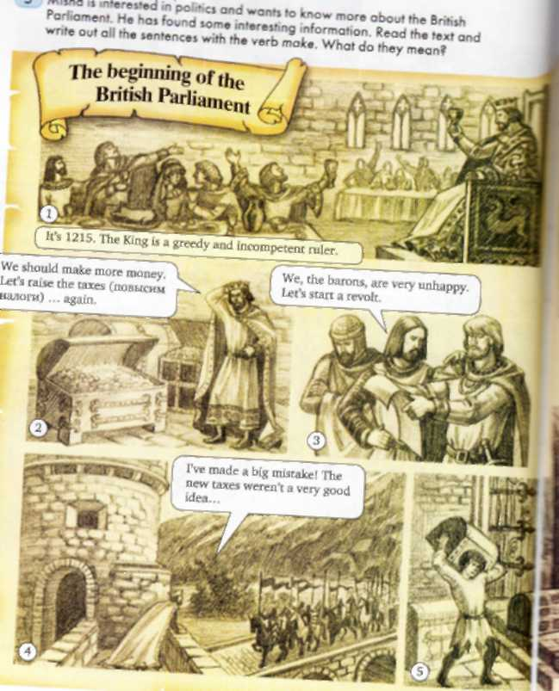

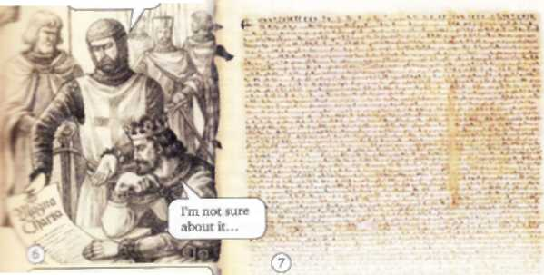

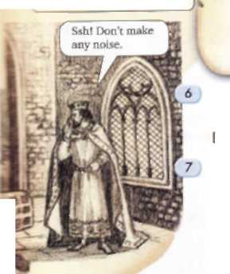

**4.Children, pay special attention to the following words. Lets revise the words . Лексическая зарядка.**

**T.:** We’ve already read the text about the Queen and the Parliament. **Now look at the screen, read and find the best translations for the words.**

The House –   
а) дворец; б) палата; в) дом.

The House of Lords –   
а) дом лордов; б) палата лордов; в) палата аристократов.

Member of Parliament –  
а) гражданин парламента; б) член парламента; в) член совета.

Hereditary peers –  
а) наследственные пэры; б) наследственные аристократы; в) наследственные члены парламента.

Life peers –  
а) пэры на время; б) пожизненные пэры; в) живые аристократы.

law –  
а) закон; б) проект; в) документ.

General election –  
а) общий конкурс; б) общественное голосование; в) общие выборы.

The House of Commons –   
а) палата простых; б) палата обычных; в) палата общин.

And what about the House of Lords?  Well. They’re not elected. Some people in the House of Lords just inherit their places from their fathers and grandfathers. They're hereditary peers. Now most people in the House of Lords are life peers. They get the title "Lord" or "Lady" for their personal achievements.

And what about the Queen? What does she do? The Queen is the head of state, She and the House of Lords have to approve (одобрить) the decisions of the House of Commons.

I want to show you a video how the opening of the Parliament happens.

**T.:** Now let`s summarize the material and do the tasks.

1. **Активизация лексического материала.**

**Fill in the gaps with the new words.**

1. In the *UK* there is no president, the Queen is ………….. of the …………..

2. There are two Houses in the Parliament: …………………….. and ………………..

3. People who sit in the ………….. Commons are called …………………..

4. People who sit in the ………………. Lords are called ……………….....

5. British people …………………... for MPs at a general …………………..

6. The party which wins a general ………………... forms the ………………. and their leader becomes the ...............................................

7. After the Queen signs the bill, it becomes the.....................

Now exchange your shits of paper and check your answers.

1. **Развитие навыков устной речи.**

**Say true or false. If false correct the sentence, please.**

1. The British Parliament sits in two buildings.

2. There is a general election when the Queen decides.

3. If there was a general election in 2004, the next general election should be in 2009 or earlier.

4. Life peers get into the House of Lords because their parents were rich.

5. Every member of the House of Lords and the House of Commons is called an MP.

6. Most members of the House of Lords are very clever and competent.

7. Members of Parliament represent everyone in the country.

8. Members of the House of Lords form the British government,

9. The Queen chooses the Prime Minister.

10. The United Kingdom is a monarchy.

1. **Развитие памяти и догадки.**

**Look at the screen, please.** I prepare a task for you about people, objects and places in the Parliament. **Look through this slide and use your brains.**

**Read the descriptions and match them with the pictures.**

1. The lords and ladies sit here. This chamber (house) is also called the Parliament Chamber. (the House of Lords)
2. When the Queen arrives in the House of Lords to open the Parliament, she sits on this. (the thrown)

c) He sits on the Woolsack (председательское место лорд- канцлера в палате лордов) and presides over the House of Lords. (lord-chancellor) Kenneth Clark

     d) He presides over the House of Commons. (the speaker) John Bercow

h) The distance between them is two swords' lengths. In the old days MPs used  to have their swords, and it was dangerous when they got angry with each other. So the lines are here to remind the MPs that they should not start a fight.

1. **Заключительная часть:**

**Teacher:**

**The conclusion:**Today you’ve learned many interesting facts about the British Parliament.

 We found out that:

1. Britain is a Parliamentary Monarchy;
2. The Parliament is a legislative branch;
3. MPs are more important than the House of Lords;
4. The party which wins the elections form the government;
5. Members of the House of Lords get their titles Lords and Ladies for their personal achievements.

Write down your homework: Ex A p 49.(in written form), learn the words p 50. Ex 6p52.

Thank you for your attention, your marks are… . The most active at the lesson were… . Give me your diaries I’ll put your marks.

Thank you for your work. You have worked hard, and I want to give you marks. So ….

Your assignment is to read the text “The Queen and the Parliament” and try to give a summary of the text.

The lesson is over . Good bye!